ST. JOSEPH CATHOLIC SCHOOL EARLY ED PROGRAM

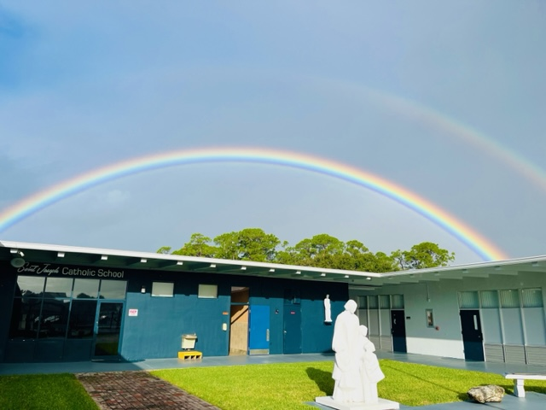

2023-2024

PARENT HANDBOOK

1

The purpose of this handbook is to acquaint families with the philosophy, policies, and procedures of St. Joseph’s Early Education program. It includes information specific to the preschool, as an integrated part of the elementary school. We look forward to sharing this special time with you and your child.

Mission

Saint Joseph Catholic School offers prekindergarten through eighth grade students the high academic standard and curriculum of the Diocese of Orlando. We recognize each student as a unique individual created in the image of God. Our community welcomes, educates, and challenges children to become lifelong learners and followers of Jesus Christ.

Philosophy

“Let the little children come to me and do not hinder them, for the kingdom of Heaven
belongs to such as these.” Matthew 19:14

At Saint Joseph Catholic School Preschool, our approach to early childhood education is centered on fostering the growth of every child in a safe, loving, and positive atmosphere. We firmly believe that each child should have the opportunity to flourish at their own unique pace and reach their full potential. Our core values revolve around nurturing socialization, cooperation, and respect within the warm embrace of our Catholic faith community.

We see ourselves as a ministry to families with young children, dedicated to providing a high-quality Catholic preschool program that meets the needs of our wonderful community. In our daily routines, we prioritize safety and love, ensuring that your child's well-being is our utmost concern. Our programs encompass a wide array of learning experiences so your child can learn through their senses, hands-on experiences, relationships, imitation, repetition, curiosity and play. We include prayers as a daily connection with Jesus and Mother Mary. These moments of reflection and devotion allow your child to grow not only in academic and social areas but also in their spiritual understanding.

We strive to create an environment where your child can flourish, feeling cherished, safe, and loved every step of the way.

Curriculum

Our developmentally age-appropriate curriculum is standards based and designed to assist the children in developing their skills and creative abilities. It has been designed for three, four and five year olds and implements socialization and kindergarten readiness skills. The children have opportunities to learn about God the Father, Jesus His Son, the Holy Spirit, the Blessed Mother and the Saints through religion lessons, daily prayer, and activities. They strengthen small & large muscles by exploring art, moving to music, and enjoying outdoor play. They enhance their speech & language development through social interaction and by enjoying story time, singing, dramatic and free play. The children gain independence and responsibility by practicing and mastering bathroom, dressing and feeding skills. Children learn cooperation, taking turns, sharing, respecting others, and how to be friends.

Enrollment Policy

Pre- Kindergarten - Age 3

Enrollment is open to any child provided the school facilities, staff, faculty, and administration are trained and able to meet the physical, behavioral and developmental needs of the child within a group setting.

Florida Voluntary Pre- Kindergarten - VPK Age 4

4 Year olds are enrolled through Brevard County Early Learning Coalition Voluntary Pre -Kindergarten program.

Americans with Disabilities Act (ADA)

St. Joseph Catholic School is in compliance with the Americans with Disabilities Act (ADA). Our school facilities and staff are up to date with all accessibility standards. We have received a commendation from the FCC for meeting special needs. Admissions policies shall not discriminate against students with disabilities of any kind if, with reasonable accommodations and no undue hardship to the school, such students can meet the school’s program requirements and parents agree with the proposed accommodations.

Attendance

School attendance is directly related to school achievement. Attendance regulations are based on Florida State Law. All students are required to attend 180 days of school. It is the parents’ responsibility to make sure their children attend school every day and arrive promptly. Students who are absent 20 days within the school year may be retained in grade in accordance with the Florida Administrative Code Rule 6M-8.305.

When a student is absent from school, parents should call the office by 9:00 a.m. each day of the absence. Upon the student’s return, parents should provide a written explanation or doctor’s note to the office. St. Joseph Catholic School adheres to the Brevard County Public School System attendance policy and State of Florida attendance laws. It should be noted that students who accumulate more than 10 days absence by mid-year, without medical or other valid written excuse, may require a report to the Florida Department of Children and Families, which may investigate the possibility of child neglect. This is the law. The school has no recourse.

Please ensure that your child’s attendance practices are in accordance with the policy. Excessive absence undermines the academic progress of our students. Should the administration determine that absences are excessive and adversely affecting the student’s progress, the classroom environment, or the school, the student may be asked to withdraw. This policy includes VPK students.
Safety of Students

Smoking is not permitted on the premises nor are any narcotics, alcohol, and other impairing drugs. Weapons are not permitted within any building OR VEHICLE or on any person on the premises, excluding law enforcement officers.

Tardiness

A child is considered tardy if not present in class when the second morning bell rings at 8:00 a.m. Tardiness interferes with the student’s academic progress, morning work routines, disrupts the teacher and the class, makes unnecessary work for the office staff, and sets a negative tone for the student’s day. Tardiness also affects the student’s attitude towards the importance of school and can instill an attitude of, “the rules do not apply to me”. In young children, it sometimes creates feelings of embarrassment and discomfort, as they walk into class late, under the eyes of their peers. It is also contrary to school policy, and may result in disciplinary action, up to, and including suspension or, in extreme cases, dismissal. Chronic tardiness may constitute a legal requirement to inform the Florida Department of Children and Families, per Florida Law 72. Students who accumulate an excessive amount of tardies each trimester will be subject to disciplinary action. Families should work together to ensure that students arrive on time. A meeting with the principal may be needed to discuss solutions to the problem.

Written Notes
Written notes are required for:
- absenteeism
- permission to leave school early or stay after school for any activity
- homework not done or incomplete work
- permission to go home with another student who is not in his/her normal carpool
- not wearing proper uniform

These permissions will not be granted over the telephone.

Make Up Work When Absent

Students will be allowed one day for each day of absence due to illnesses for make up work. If the absence is prolonged special arrangements may be made with the teachers involved to make up the work within a reasonable time. Parents should contact teachers to arrange to pick up any missed work. Extended periods of absence interfere with the continuity of student learning and are discouraged. When students will be absent due to extended trips, make up work may not always be available before they leave. Students will be required to do make up work upon return either before school or after school, but not during classroom time.

Toileting Expectations

We expect our students to be able to use the toilet independently and do the following:
- Be able to tell an adult they have to go the restroom before they go.
- Be able to pull down their underwear and pants and get them back up without assistance.
- Be able to wipe themselves after using the toilet.
- Be able to wash and dry hands.
- Be able to postpone going if they must wait for someone who is in the restroom.

If a PreK-3 or VPK student has a toileting accident and can change him/herself, then our teachers can oversee this. If a student is unable to change him/herself, it will be necessary to call parents/guardians to assist the child so he/she may return to class. Parents/guardians
will provide a change of clothing for their children to keep on the school’s premises in case of an accident. If a child has more than three accidents in quick succession, we may ask that the child stay home from school for a week or so to enable the family to work with him/her on a more constant basis to ensure that the child is fully potty trained. This is usually highly effective. Unfortunately, due to the strict guidelines dictated by the state, if a child consistently has accidents, our only recourse will be to suggest that he/she is not ready for preschool at this time. This situation is very rare and will be our last resort.

Behavior Management

Behavior is handled positively with consideration of the child’s age and development. Positive reinforcement and redirection are the most common methods, along with room management, careful supervision, consistent schedules, clear classroom expectations, and well-thought out day-to-day lesson plans. Requiring children to sit down and “think about” their behavior will be used only when necessary. We will share with parents any concerns or extreme behaviors that are not age appropriate.

Biting

Biting is a normal occurrence as children grow and develop. Close supervision, classroom structure, and overall planning are methods we use to minimize biting; however, when biting occurs the victim will be treated first according to their emotional and physical needs and then the biter’s behavior will be addressed and redirected. A report will be made to the parents/guardians of both parties, but identification of the child doing the biting is against the law. All biting issues will be addressed on a case-by-case basis. To learn more about biting and why children bite, visit the American Academy of Pediatrics website. However, should biting become excessive the principal has the right to remove children from the program.

Arrival

All preschool students will be walked to their classroom.
Communication

All Saint Joseph families will receive communication electronically from the school on a regular basis, which contains information pertinent to this campus and its programs.

Some teachers may use additional current texting or e-mail Apps or programs to communicate with parents.
Parents are encouraged to communicate with teachers and the school office with questions, concerns, and other important information that may affect your child. Open, consistent, and regular communication is one way to ensure both you and your child have a positive experience at our school.

Snacks and Lunch

We will have a scheduled snack time each day. Please send in a healthy snack and drink for your child each day. Water is encouraged and we will refill water bottles as needed. Students who stay for extended care will eat lunch at school. They will need to either bring a lunch and drink or purchase the lunch provided by the school cafeteria. If you would like your child to purchase lunch you will need to pay through the FACTS payment management system. Our school menus are provided to parents on our school-wide weekly newsletter.

We encourage meals and snacks to meet daily nutritional needs of children according to the USDA MyPlate. Copies of the USDA MyPlate can be found at the website http://www.choosemyplate.gov . We encourage families to follow USDA MyPlate, if food is brought from home.
- Children are encouraged to serve themselves and assist with cleanup, within age-appropriate levels of ability.
- Microwaves are not used for any student’s food.
- Any food intended to be shared is commercially prepared and packaged or are whole fruits.
- Staff does not offer children younger than four the following foods: hot dogs, whole grapes, nuts, popcorn, raw peas, hard pretzels, spoonfuls of peanut butter, chunks/raw carrots or meat pieces too large to be swallowed whole.

Uniforms

Saint Joseph students wear uniforms in both PreK-3 and VPK. Our uniforms consist of blue Saint Joseph logo shorts, blue Saint Joseph logo t-shirts, white socks, and shoes. For the safety of the children during outside playtime, closed toed shoes such as sneakers with nonskid soles are required. Children will not be allowed to participate on climbing equipment with sandals or smooth soled shoes such as boots and dress shoes. Shoes with Velcro that your child can fasten independently are preferred.

During colder weather, students may wear their blue Saint Joseph logo sweat pants and blue Saint Joseph logo sweatshirts. Students may also wear their blue Saint Joseph jacket with logo. Students may also wear long-sleeved undershirts; however, they may only be solid navy blue or white with no decorations or designs. Both new and used uniform sales are scheduled at the school throughout the school year. You may also purchase uniform items at Sir Walters Uniforms located at 500 S Plumosa St, Merritt Island, FL 32952. Their website is https://store.sirwalteruniforms.com/schools/st-josephs-palm-bay.html Makeup including nail polish and jewelry, other than small stud earrings for girls with pierced ears, is not allowed.

N.U.T. DAYS

N.U.T. (No Uniform Today) Days are scheduled throughout the school year. Students will be notified of any special occasions when they are allowed to wear N.U.T. day clothing. Students may choose to donate $1.00. N.U.T. days are run by the Student Service Council, and the monies collected go to a wide variety of charitable causes. Appropriate N.U.T. Day attire includes closed toed shoes with nonskid soles. Students may not wear pajamas, tank tops, shirts that show a bare midriff or have inappropriate sayings on them.

Toys from Home

We ask that toys from home not be brought to school.

Birthdays

Birthdays are an important part of your child’s life. Parents are invited to provide a store-bought treat, for the entire class, for their child’s birthday. Please work out the details with your child’s teacher. Also, we ask that no invitations be brought to school to pass out unless the entire class is included.

Health/Illness Policy

We will always err on the side of caution when it comes to the health and wellbeing of your child.

Your child’s health is very important to us. We cannot accept any sick children at our school. A child who is sick exposes the other children and our staff to illness. If your child becomes ill while here, you will be contacted immediately.
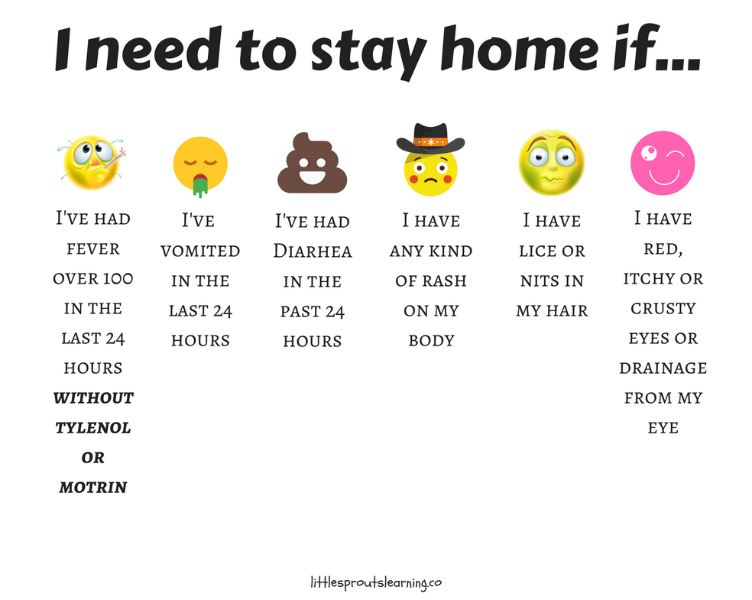

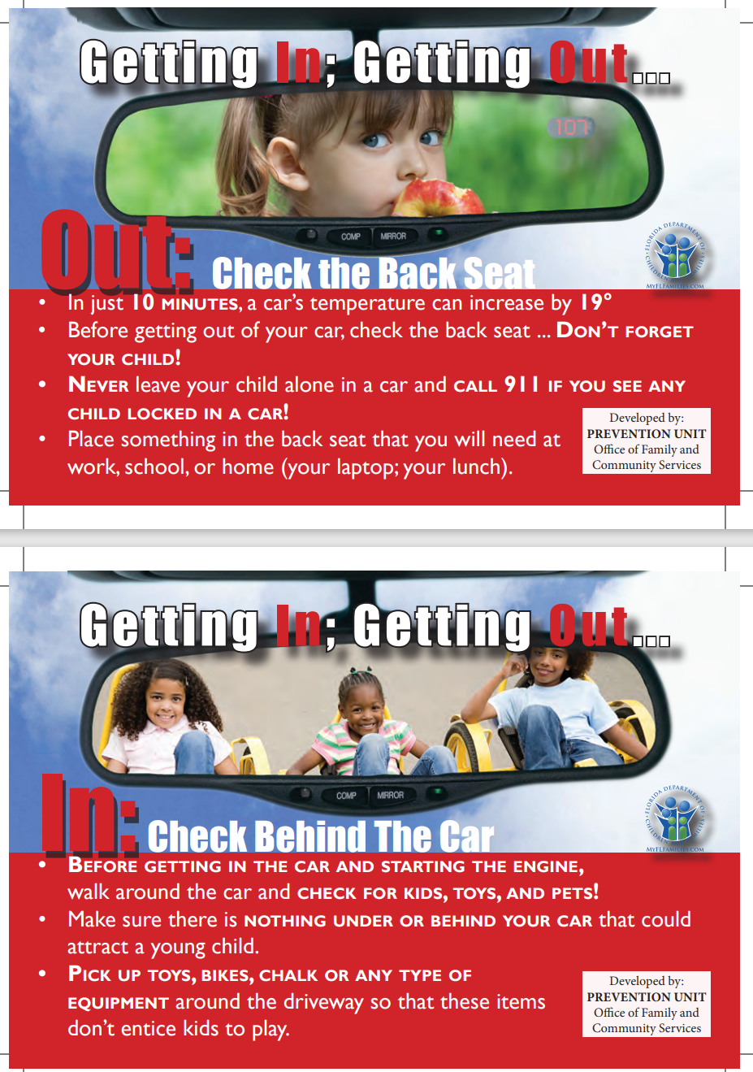
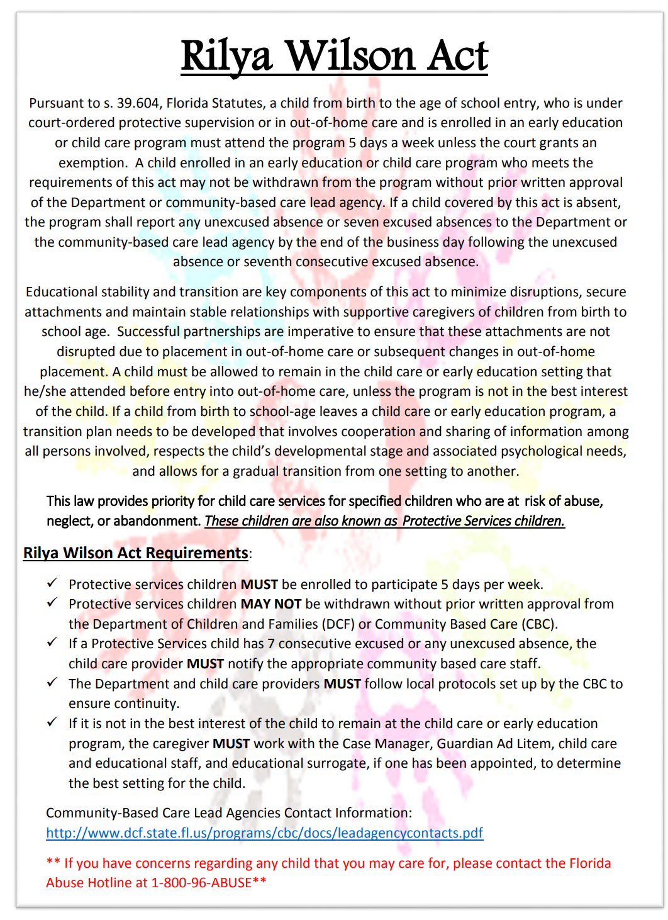
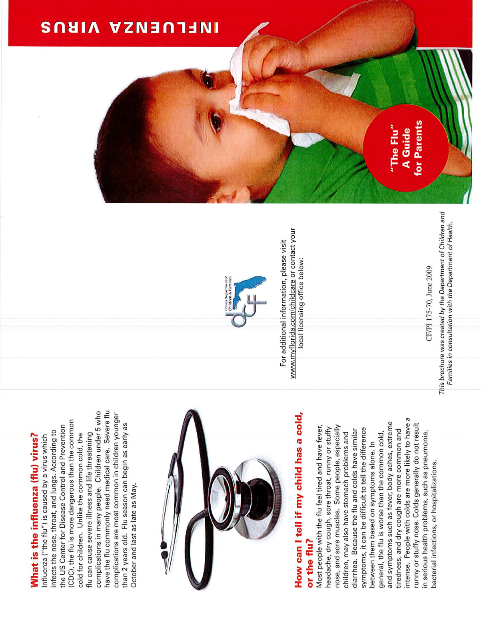

HANDBOOK ACKNOWLEDGEMENT

I ACKNOWLEDGE THAT I HAVE READ THE CONTENTS OF THE ST. JOSEPH CATHOLIC SCHOOL PARENTS/STUDENT HANDBOOK. I further understand that, because it is impossible to foresee all problems which may arise, the faculty and administration of St. Joseph Catholic School are empowered to take disciplinary action against any behavior which violates the spirit and philosophy of SJCS, even though not specified in this handbook. Additionally, the school administration retains the right to amend the handbook for a just cause.

Student Name (PRINT): _________________________________________________

Parent Name (PRINT): __________________________________________________

Parent signature: _______________________________________________________

Date: ______________________

